Launching of Insurance Awareness Campaign –
A collaborative effort of IRDA of India and Government of Tripura

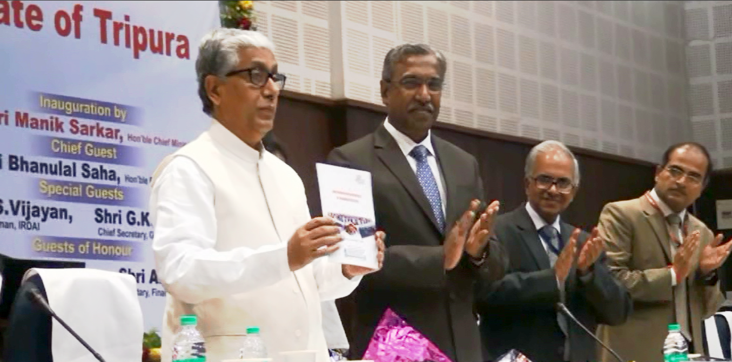
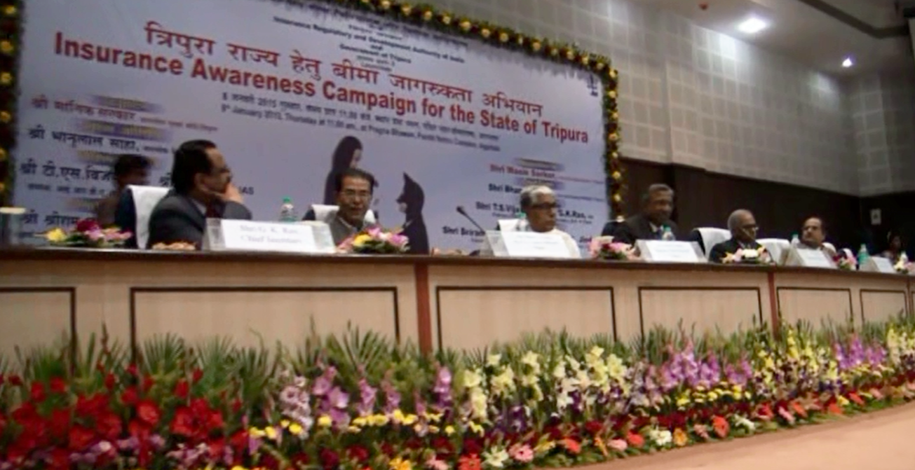

- The Insurance Awareness Campaign in the State of Tripura was launched on 8th January, 2015 at Agartala by the Hon’ble Chief Minister of Tripura Shri Manik Sarkar. The Campaign is a collaborative effort of Insurance Regulatory and Development Authority of India and Government of Tripura.

- The campaign aims at achieving 100 per cent financial literacy and 100 financial inclusion in the State of Tripura. The objective is proposed to be achieved within an outer time limit of two years through a wide range of activities, by adopting a multi-institutional approach (Insurers, Life and General insurance councils, banks, Financial Literacy Centres, Common Service Centres etc.) and a multi-pronged strategy (Seminars at State and District levels, village adoption, educating students, use of media – print and electronic, distribution of education material etc.).

- Shri A. Jindal, Secretary, Finance, Government of Tripura welcomed the participants. Shri G.K. Rao, Chief Secretary, Government of Tripura gave a brief outline of the demography and socio-economic background of the State of Tripura setting the context for the need for a campaign to promote insurance awareness and thereby promote insurance inclusion in the State.

- In his addressed, Shri Bhanulal Saha, Hon’ble Minister of Finance, Government of Tripura impressed upon the importance and need for insurance of life, property, business and health for dealing with the economic impact of risk in day-to-day life, thereby making it beneficial both socially and economically.

- Shri TS Vijayan, Chairman, IRDA of India gave a brief outline of initiatives of IRDAI ensuring that adequate infrastructure is created for expanding the reach of insurance in the country which include greater number of insurers in public and private sector, a large number and diverse kinds of insurance intermediaries, a wide range of insurance products and a fairly robust regulatory, supervisory and policyholder protection framework. He also apprised the members of the various consumer education initiatives taken by IRDA and those planned in future. He stated that given the insurance infrastructure, once the members of public realize the need for and benefits of insurance, the demand for insurance would automatically increase, which in itself would trigger greater insurance inclusion.

- Hon’ble Chief Minister of Tripura, Shri Manik Sarkar, lauded the efforts of IRDAI over the years in regulating and developing the insurance sector. He reflected upon the potential of insurance inclusion in the State of Tripura which can be realized provided the benefits of insurance are made known to members of public and businesses in the State. He requested all the institutions in the State - Government, non-governmental, educational etc. to get actively involved in the task of promoting insurance awareness so that much before the targeted time of two years, The State of Tripura would be 100 % insurance literate and 100 % insurance included not only in life and health but also in non-life insurance, thereby proving to be a Model State in the country. He thanked IRDAI for choosing State of Tripura for the maiden collaborative insurance awareness campaign. and assured full support of the entire State machinery in achieving the targets set forth. The Chief Minister launched the booklet outlining the Action Plan of the Insurance Awareness Campaign in Tripura. In order to curb the menace of spurious callers, IRDA has initiated a TV campaign on Pan-India basis along with a documentary film showing glimpse of the actin plan of the insurance awareness campaign proposed for Tripura State. The Bengali version of TVC under IRDA’s ad campaign against spurious callers was also launched on this occasion.

- More than 250 participants representing Panchayats, local government bodies, district administration, insurance sector, consumer bodies, insurance councils, members of press etc. attended the launching ceremony. The occasion was also marked by the release of three IRDA handbooks titled “Introduction to Insurance”, “Employment opportunities in the insurance sector” and “Handbook on Insurance” focusing on right buying.

